For foreigners,

In this season, floods and landslides may be caused by torrential rain in Japan.

Please pay attention to the weather forecast and information from your local government. Check for where to evacuate near your home.

If you feel your safety is in danger, evacuate immediately.

　Please also check the following apps and websites.

◎「Safety tips」　　　　　　 ◎「NHK WORLD-JAPAN」（アプリ）



FOR Android 　　　　　　　　　　　　　　　　　FOR Android



FOR iPhone 　　　　　　　　　　　　　　　 　　FOR iPhone

◎「Japan Safe Travel」

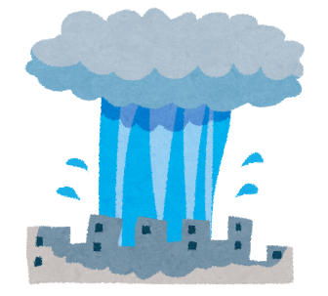https://twitter.com/JapanSafeTravel



◎「NHK WORLD-JAPAN」（ホームページ）

https://www3.nhk.or.jp/nhkworld/en/news/tags/31/